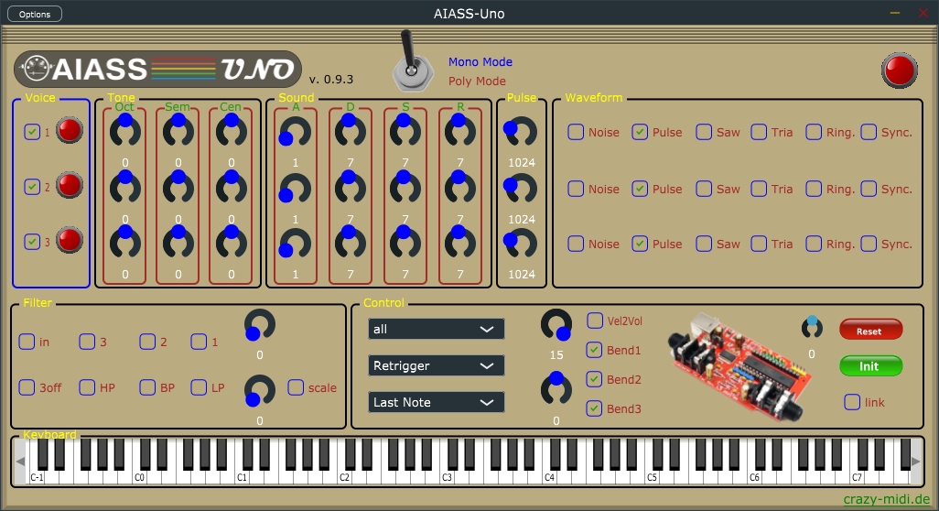
AIASS-Uno-VST

A VST for the SIDBlaster-USB

Programming and UI design by Andreas Schumm
Copyright © 2022
www.crazy-midi.de
English manual with help from Magnus Hansson
version 0.9.3

AIASS Is A SID Synthesizer
Index
General information 3
Hardware installation 4
SID-chip installation 4
Jumper settings 5
For the 6581 SID-chip: 5
For the 8580 SID-chip: 5
Other jumpers on the hardware 6
JP6 (White) 6
SV2:Paddle connector (yellow) 6
SV1: ISP Connector 7
USB and audio connections 7
USB jack 7
Audio-out jack 8
Audio-in jack 8
Software installation 9
The FTDI D2XX driver 9
Windows 9
Linux 10
MacOS 10
The hardsid library 11
Windows 11
Linux 12
MacOS 12
SIDBLASTERUSB_WRITEBUFFER 12
Windows 12
Linux/MacOS 12
The SIDBlasterTool 13
Notes for developers 13
AIASS-Mono-VST 14
Install the VST 14
Windows: 14
Linux 15
MacOS 15
Power LED 15
Poly/Mono Switch 16
Keyboard Section 16
Voice Section 16
Master section: 17
Volume & Vel2Vol 17
MIDI & Keyboard Playmodes 17
Midi Channel select 17
Play mode 18
Note priority mode 18
Pitchbend 18
Reset & Ini 19
Link Button 19
Tune Slider 19
Oscillator and envelope section: 19
Oscillator Pitch section 21
ADSR envelope and Pulse Width 21
Waveforms and Noise 22
Ring modulation 22
Ringmod.1 22
Ringmod.2 22
Ringmod.3 22
Sync. 23
Sync. 1 23
Sync. 2 23
Sync. 3 23
Filter section 23
In 23
Filter activation buttons 24
Scale button 24
Filter types 24
Freq. 24
Res. 24
MIDI Implementation 25
Tips 26
Links 27
Thanks to 28

General information

- Plug and play is not possible, the SIDBlaster must be plugged in before using in an application. Also, do not unplug the SIDBlaster before you have finished the application.
- When you are not using the SIDBlaster it is recommended to unplug the USB-connection since this prolongs the life of the SID-chip.
- Since a SID-chip produces heat, use a heatsink on the chip if possible and make sure there is sufficient ventilation.

Hardware installation

SID-chip installation
Warning! Double check the voltage settings on the SIDBlaster hardware. If you set them incorrectly, for example sending 12V into an 8580 SID-chip which runs at 9V, you will destroy the chip. If you have a multi-meter, check the voltage at the SID chip socket to be sure.
Always use an anti static bracelet to avoid damaging the SID-chip and other electrical components when installing it in the SIDBlaster.
To remove a SID chip, for example, use a screwdriver, lever it out alternately, be careful not to damage the circuit board or components.
Before inserting a SID, bend the legs straight with a pair of pliers, press carefully, check that none of the legs bend over.
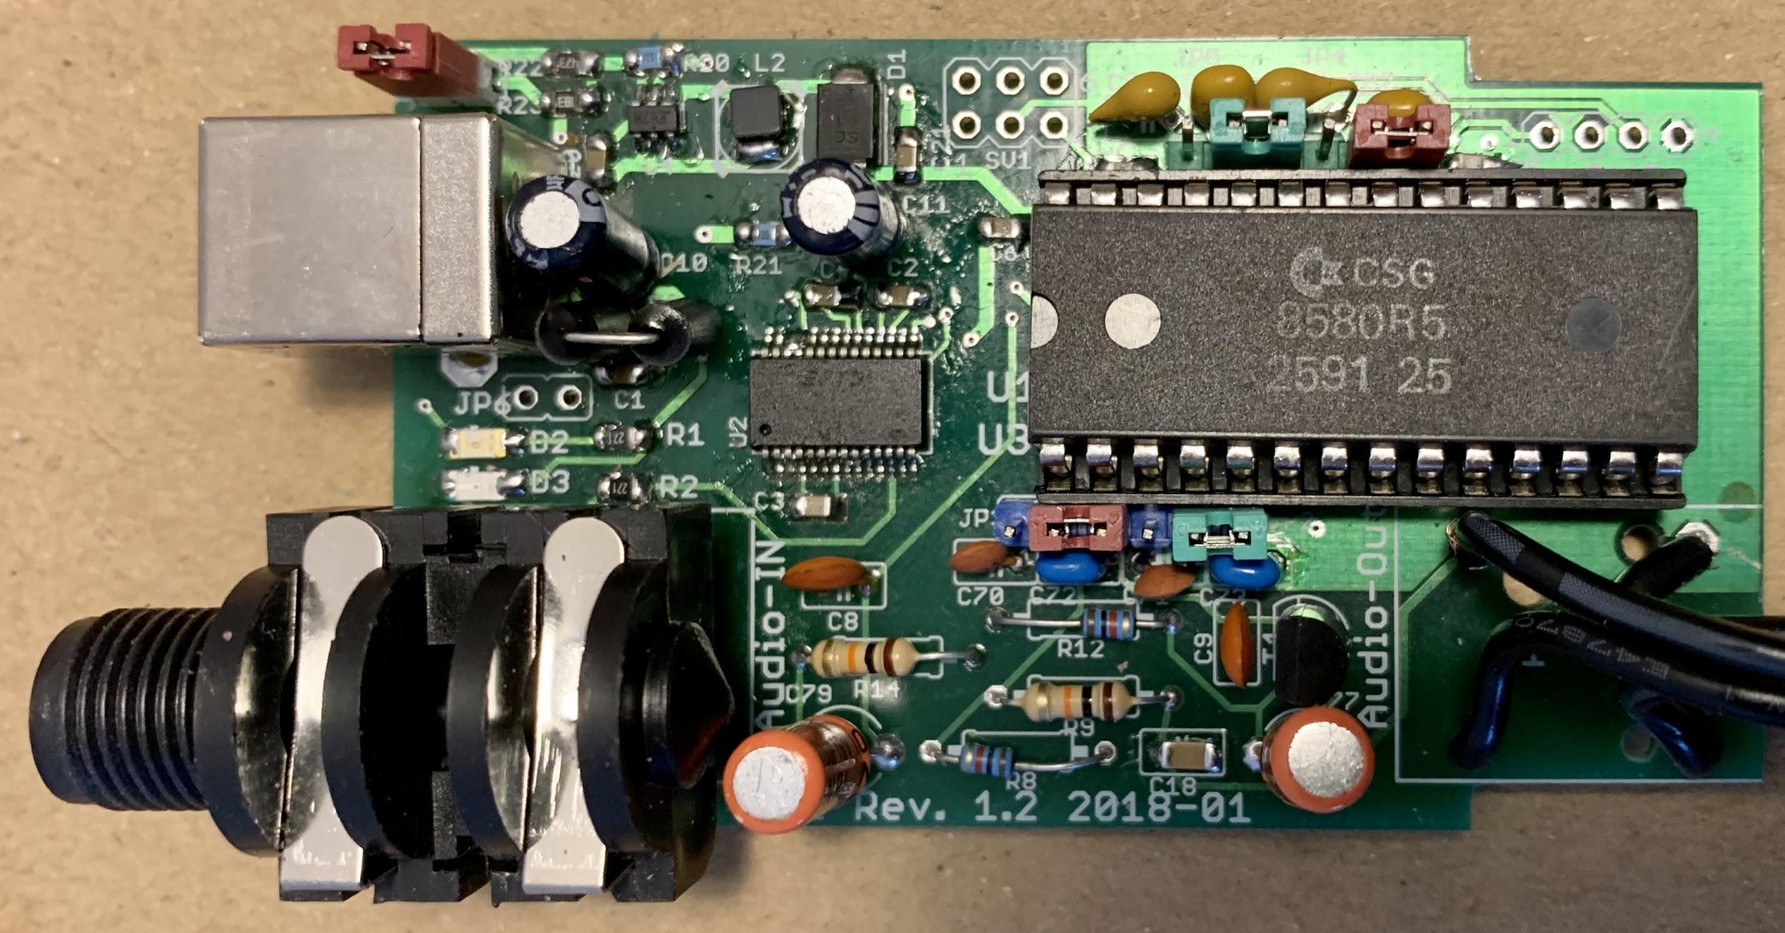A SIDBlaster-USB with correct installed 8580

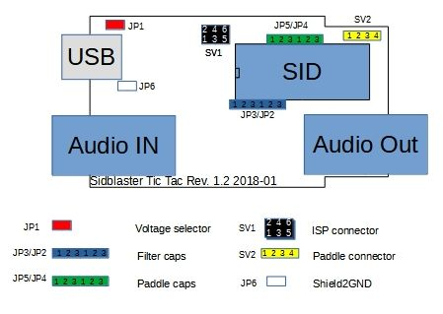
Jumper settings

For the 6581 SID-chip:
- JP1: must be open (12V).
- JP2-JP5: Place all jumpers on the left side (pins 1-2).

For the 8580 SID-chip:
- JP1: must be closed (9V).
- JP2-JP5: Place all jumpers on the right side (pins 2-3).

Other jumpers on the hardware

JP6 (White)
From Rev. 1.2 and on. Experimental, connects USB shield to ground; you may try it to counteract interfering noise.

SV2:Paddle connector (yellow)
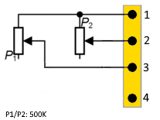
Here you have access to the two A/D converters of the SID chip. For example, you can connect 2 rotary potentiometers as paddles. This is of interest for programmers. You can also use the function with the SID object for Max/MSP.
1 | +5V
2 | POTX
3 | POTY
4 | GND

SV1: ISP Connector
Use a Picit 3 programmer to flash the microcontroller. MPLAB IPE is used as software.
1 | MCLR/VPP
2 | +5V
3 | GND
4 | PGD (ICSPDAT)
5 | PGC (ICSPCLK)
6 | n.c.
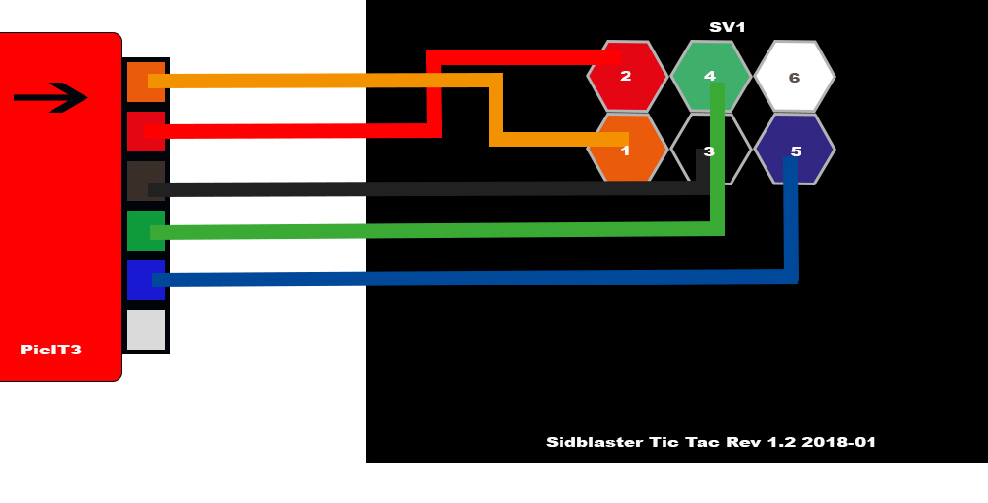

USB and audio connections

USB jack
Connect the SIDBlaster hardware to a USB port using a type A-B USB cable of good quality. It can also work with a good quality USB-hub.

Audio-out jack
The audio output is designed as a professional 1/4 "jack socket. Connect the audio output of the SIDBlaster to your mixer or audio interface using an unbalanced (mono) cable.

Audio-in jack
The second audio jack on the SIDBlaster is an audio input and is also an unbalanced connection. If you are unsure which connector is which, the connectors are marked on the PCB. Be careful about what you connect to the input of the SID-chip. These chips are old and very sensitive to electrical spikes and too high voltages.

Software installation

The FTDI D2XX driver

Windows
The SIDBlaster needs to do a digital "handshake" the first time it is connected via USB. This requires an internet connection. The handshake will not work if your internet connection is set to “Metered Connection” in Windows. To solve this, temporarily disable “Metered Connection”, wait a moment for the SIDBlaster to do the handshake, and then re-enable “Metered Connection”.
The latest Windows versions provide the FTDI driver via the update function. So check: Settings / Updates / Optional Updates.
The SIDBlaster is recognized by Windows as a “USB Serial Converter”. It may be recognized as a COMx device with ports (in Device Manager). Edit: Your SIDBlaster have to be flashed correctly with the FTDI prog tool and the template from the SIDBlaster project in this case. The actual hardsid.dll don't accept incorrect flashed SIDBlasters.
With older versions of Windows, installation of a driver by FTDI may be necessary, available at: http://www.ftdichip.com/Drivers/D2XX.htm.

Linux
Download D2XX driver from: https://ftdichip.com/drivers/d2xx-drivers/
Please install FTDI drivers explained in chapter '2 Installing the D2XX driver' from here: https://www.ftdichip.com/Support/Documents/AppNotes/AN_220_FTDI_Drivers_Installation_Guide_for_Linux.pdf
If device still cannot be used, please install a workaround mentioned in chapter '1.1 Overview' :
$ sudo vi /etc/udev/rules.d/91-sidblaster.rules
ACTION=="add", ATTRS{idVendor}=="0403", ATTRS{idProduct}=="6001", MODE="0666", RUN+="/bin/sh -c 'rmmod ftdi_sio && rmmod usbserial'"
$ sudo udevadm control --reload-rules && udevadm trigger

MacOS
Note: it may be necessary to switch off the security monitoring in MacOS or to authorize all developers.
sudo spctl –master-disable
The following could also work:
sudo xattr -rd com.apple.quarantine / Your software path.app
Download and install D2XX Driver from: https://ftdichip.com/drivers/d2xx-drivers/
use the instructions from: https://ftdichip.com/wp-content/uploads/2020/08/AN_134_FTDI_Drivers_Installation_Guide_for_MAC_OSX-1.pdf
Download and install D2XXHelper from the same site.

The hardsid library
Is the “driver” of the SIDBlaster, so to say. Under Windows it comprises a reprogrammed DLL of the Hardsid, thus, software programmed for the Hardsid becomes compatible for the SIDBlaster. Later the DLL was ported to Linux and MacOS. The DLL is made and maintained by Stein Pedersen. Linux/Mac port was made by Ken Händel.

Windows
- Download from:
https://github.com/gh0stless/SIDBlaster-USB-Tic-Tac-Edition/tree/master/hardsid_library
- Copy the right hardsid.dll into the program directory of the program with which you want to use it.
- The 64 bit version is required by the 64 bit version of vice and also by the 64 bit versions of AIASS.

Linux
- Download from:
https://github.com/gh0stless/SIDBlaster-USB-Tic-Tac-Edition/tree/master/hardsid_library
- copy libhardsid.so to /usr/local/lib/
- apply chmod 0755 on libhardsid.so
- copy hardsid.hpp to /usr/local/include/

MacOS
- Download from:
https://github.com/gh0stless/SIDBlaster-USB-Tic-Tac-Edition/tree/master/hardsid_library
- copy libhardsid.dylib to /usr/local/lib/
- copy hardsid.hpp to /usr/local/include/

SIDBLASTERUSB_WRITEBUFFER
Depending on your system, tunes with high data rates (multi speed tunes or digitunes) may play slower if the latency of the USB driver is too high. This can be remedied by setting the driver write buffer size to a smaller value, for instance. Even down to 0, works on fast machines.

Windows
set SIDBLASTERUSB_WRITEBUFFER_SIZE=8

Linux/MacOS
export SIDBLASTERUSB_WRITEBUFFER_SIZE=8

The SIDBlasterTool
With SIDBlasterTool you can check if library and device communication works.
You can also set the SID type and change the serial number. The type is saved as part of the device description and evaluated by applications such as JSIDPlay.

Notes for developers
For developers who want to write applications using the hardsid library, I refer to hardsid.hpp. You can find a few more tips in the AIAS-VST repository in the doc folder. Do not forget to call the destructor method manually when exiting under MacOS and Linux.
Detailed instructions on how to create the hardsid library can be found here (thanks to Ken Handel): https://haendel.ddns.net/~ken/sidblaster.html

AIASS-Mono-VST
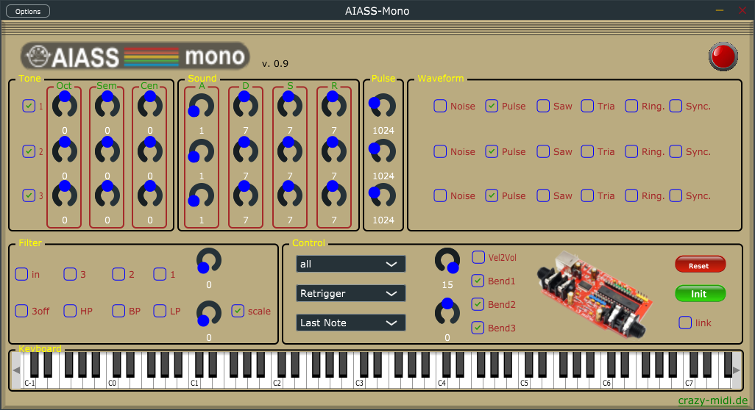
The plug-in is available in three variants for each system: VST2, VST3 and standalone version.

Install the VST

Windows:
Copy the AIASS-Mono.dll into your VST2 directory.
Copy the AIASS.vst3 into your VST3 folder.
Copy the hardsid.dll into the program folder of your DAW host program and into the VST3 folder .
If you want to use the standalone version, make sure that the hardsid.dll is in the same folder. Set a correct audio output in the options of the standalone version, even if the program itself does not emit any sound.

Linux
Copy the VST "and the VST into your respective folder (for me ~/.VST and ~/.VST3).
FTDI driver and hardsid library must be installed correctly.
The standalone version can only be started via the terminal.

MacOS
Copy the VST2 and VST3 into the respective folders in:
~/Library/Audio/Plug-Ins/
FTDI driver and hardsid library must be installed correctly.
You may need to take steps to ensure that apps are run by non-Apple-licensed developers. It may be necessary to switch off the security monitoring in MacOS or to authorize all developers.
sudo spctl –master-disable
Could also work:
sudo xattr -rd com.apple.quarantine / Your software path.app

Power LED

If the Power LED flashes there is an error. This could mean that the hardsid.dll file is not found or that the computer can not find the SIDBlaster hardware. In normal operation the LED indicates incomming MIDI messages.

Poly/Mono Switch

This switch toggles between poly and mono mode. Note that the sound of each voice can also be set differently in polymode.

Keyboard Section
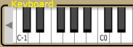
Shows incoming MIDI notes, and you can play notes, note that the position on the key determines the velocity. Only plays on MIDI channel 1.

Voice Section
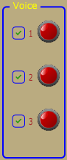
You can use the checkboxes to select or deselect voices. This only works in mono mode. The LEDs indicate the triggering of the voices.

Master section:
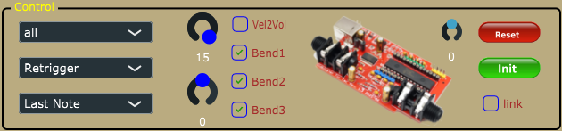

Volume & Vel2Vol
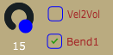
Master volume. To get the best possible signal to noise ratio, it is best to leave it a 15.
Vel2Vol When activated velocity will control Master volume.

MIDI & Keyboard Playmodes
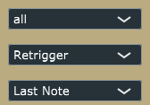

Midi Channel select
Setting the MIDI channel to be used for listening.

Play mode
- Retrigger - Notes are retriggered every time a key is pressed, but if more than one key is held, the note will return to its previous pitch after the second key is released,
- Legato - Notes are played Legato, i.e. the pitch "glides" between notes.
- Last step - Notes are retriggered every time a key is pressed, and if more than one key is held the previous note will be cut off.

Note priority mode
- Last Note priority prioritises the last Midi note when several notes are pressed.
- High Note priority prioritises the highest Midi note when several notes are pressed.

- Low Note priority prioritises the lowest Midi note when several notes are pressed.

Pitchbend
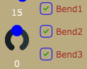
Represents the PitchBend controller, with the 3 buttons you can select which voices you want to influence with Pitchbend. (Up/Down 1 Octave.)

Reset & Ini
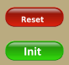
The SID chip can get into an undefined state, with Reset you can reset it, your settings are retained. Init is a SID-reset and a simultaneous reset to factory settings.

Link Button

Links the controls for oscillator tuning, ADSR and Pulse Width, which is helpful when adjusting the sound for all oscillators at the same time. If unchecked, all controls are edited one by one.

Tune Slider

Due to the hardware, your SIDBlaster will not be 100 percent correct. Use a tune utility, such as a plugin in your DAW, to tune this knob (+/- 100 cents).

Oscillator and envelope section:
There are 3 oscillators on a SID chip, each with its own ADSR envelope hardwired to the VCA (Voltage Controlled Amplifier), i.e. creating a volume envelope. The filter is not connected to an envelope on the SID chip by design.
However, there are ways around this as described in the tips section.

Oscillator Pitch section
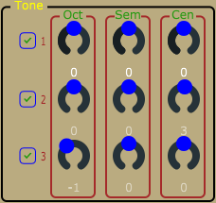
The oscillator pitch can be changed using the:
Oct = Changes the oscillator pitch up or down in one octave steps
Semi = Changes the oscillator pitch up or down in semitone steps
Cent = Fine tunes the oscillator pitch

ADSR envelope and Pulse Width
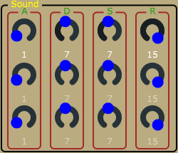

ADSR = As mentioned above, each oscillator has its own ADSR envelope. It allows control of the Attack, Decay, Sustain and Release time of each oscillator's VCA (Volume envelope).
Pulsew. = This controls the Pulse Width for each oscillator. It is particularly useful when using the Pulse waveform.

Waveforms and Noise
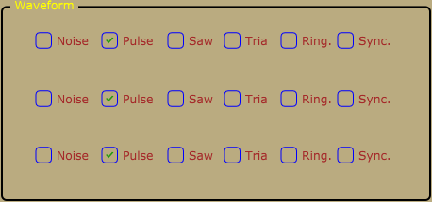
Each oscillator has three waveforms, Pulse, Saw and Triangle, plus Noise. Several waveforms can be selected at the same time. However, the noise can not be combined with the other waveforms.

Ring modulation
This effect is only audible when the Triangle wave is activated.
Ringmod.1 | Activates the Ring Modulation on Voice 1.  The Oscillator must be set to Triangle Wave.  It is a ring modulation of voice 1 and voice 3.
Ringmod.2 | Activates the Ring Modulation on Voice 2.  The Oscillator must be set to Triangle Wave.  It is a ring modulation of voice 2 and voice 1.
Ringmod.3 | Activates the Ring Modulation on Voice 3.  The Oscillator must be set to Triangle Wave.  It is a ring modulation of voice 3 and voice 2.

Sync.
Synchronizes the Oscillators to each other.
Sync. 1 | Activates the Oscillator Sync on Voice 1.  This syncs Voice 1 with Voice 3.  The frequency of Voice 3 must be lower than Voice 1 for it to have any audible effect.
Sync. 2 | Activates the Oscillator Sync on Voice 2.  This syncs Voice 2 with Voice 1.  The frequency of Voice 1 must be lower than Voice 2 for it to have any audible effect.
Sync. 3 | Activates the Oscillator Sync on Voice 3.  This syncs Voice 3 with Voice 2.  The frequency of Voice 2 must be lower than Voice 3 for it to have any audible effect

Filter section

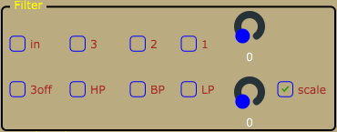
In
There is an option to activate the filter for the external input. This will raise the noise level since the input of a SID-chip is quite noisy by design. Actually, the SID-chip is pretty noisy, but that’s also part of the charm. As mentioned above, please be careful about what you connect to the input of the SID-chip. SID-chips are old and very sensitive to electrical spikes and too high voltages.

Filter activation buttons
The filter is activated for each oscillator separately (oscillator 1-3).

Scale button
There are two main types of SID-chip, the 6581-version and the newer 8580-version. The main difference is the filter. The 8580-version has an updated filter where the resonance control is more effective. The cutoff characteristics are also different between the two chips. The two modes of this button sets the cutoff scale for the 8580 and 6581 respectively. Try both scales, it might sound nice.

Filter types
- LP = Low Pass
- BP = Band Pass
- HP = High Pass
All filter types can be freely combined.

Freq.
Changes the filter Cutoff Frequency for all oscillators which have their filter activated.

Res.
Changes the Resonance amount for all oscillators which have their filter activated.

MIDI Implementation
Octave1 | CC78
Octave2 | CC85
Octave3 | CC88
Semi1 | CC79
Semi2 | CC86
Semi3 | CC89
Cent1 | CC70
Cent2 | CC87
Cent3 | CC90
Attack1 | CC73
Attack2 | CC20
Attack3 | CC25
Decay1 | CC75
Decay2 | CC21
Decay3 | CC26
Sustain1 | CC76
Sustain2 | CC22
Sustain3 | CC27
Release1 | CC72
Release2 | CC23
Release3 | CC28
PulseW.1 | CC77
PulseW.2 | CC24
PulseW.3 | CC29
Cutoff | CC74
Resonance | CC71
SID-Volume | CC07
Pitchbend | Pitchbend

Tips

- Add LFO’s.
- Add ADSR-envelopes.
- Lower the AIASS the Decay and Sustain settings if you get internal distortion. The SID-chip distorts quite easily, especially when playing all oscillators at the same time.
- Try an Arpeggiator with a fast tempo on the Mono version of AIASS to get classic Commodore C64 arpeggiated "chords".

Links

- http://crazy-midi.de/
- https://github.com/gh0stless/SIDBlaster-USB-Tic-Tac-Edition
- https://github.com/gh0stless/SIDBlasterTool
- https://github.com/gh0stless/sid-object
- https://github.com/gh0stless/AIASS-for-MAX4LIVE
- https://github.com/gh0stless/AIASS-Mono-VST
- https://github.com/Galfodo/SIDBlasterUSB_HardSID-emulation-driver
- https://vice-emu.sourceforge.io/
- https://www.acid64.com
- http://www.gsldata.se/c64/spw/ (SIDPlay2)
- https://haendel.ddns.net/~ken/ (JSIDPlay2)
- https://sourceforge.net/projects/goattracker2/
- https://www.facebook.com/groups/2305052182957954/

Thanks to

- Davey (The Phantom) for creating the original SIDBlaster.
- Wilfred Bos for his tips and helping.
- Stein Pedersen for his assistance and the sidblaster.dll.
- Ken Händel for his JSIDPlay2 and his work on the library
- Rico Frenzel for help and testing.
- Karl-Werner Riedel for his help with designing the TicTac hardware.
- Magnus Hansson for writing parts of this original manual.
- Yvonne Hölzel for proofreading.
- Borjana Konstantinowa for her patience with me.
Coswig, Saxony 22/02/02

